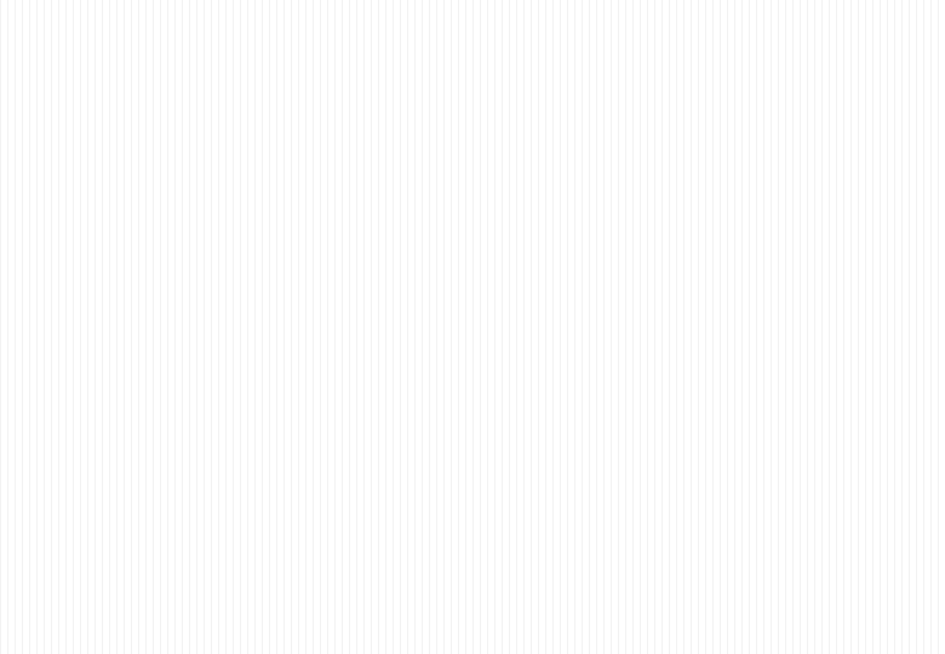

2022

JANUARY
SUN | MON | TUE | WED | THU | FRI | SAT
 |  |  |  |  |  | 1
2 | 3 | 4 | 5 | 6 | 7 | 8
9 | 10 | 11 | 12 | 13 | 14 | 15
16 | 17  Orientation:  10~11  ①Korean language class:  11~13  ①Language Exchange:  14~16 | 18  ② Korean language class:  9~12  ② Language Exchange::  13~15 or14~16 | 19  ③ Korean language class:  9~12  ③ Language Exchange::  13~15 or 14~16 | 20  ④ Korean language class:  9~12  ④ Language Exchange::  13~15 or 14~16 | 21  ⑤ Korean language class:  9~12  ⑤ Language Exchange::  13~15 or 14~16 | 22
23/30 | 24/31  ⑥ Korean language class:  9~12  ⑥ Language Exchange::  13~15 or 14~16 | 25  ⑦ Korean language class:  9~12  ⑦ Language Exchange::  13~15 or 14~16 | 26  ⑧ Korean language class  9~12  ⑧ Language Exchange::  13~15 or 14~16 | 27  ⑨ Korean language class  9~12  ⑨ Language Exchange  13~15 or 14~16 | 28  Closing ceremony:  10~11 | 29

